
University of Engineering and Technology,
Lahore
Department of Computer Science

Project Report
Team Members
Name Roll Number Email
Zarfishan Maqbool 2025-CS-105 zarfishank454@gmail.com
Alisha Rehman 2025-CS-103 alishaniazi111@gmail.com
Session: Fall’25 Morning Section: B Semester: 1st

Course: CSC101 - Discrete Mathematics Teacher: Mr. Waqas Ali
January 1, 2026

CSC101 - Discrete Mathematics 2025-CS-XXX
Contents
Project Report 0
1. Project Title 0
2. Chosen Track 0
3. Overview 1
4. Summary 1
5. Technology Stack & Libraries Utilized 2
6. List of Features 2
7. Mathematical Foundations 3
8. Examination of Key Functions/Methods 4
9. Limitations 9
10. User Interface 9
11. Future Improvements 15
12. Conclusion 16
13. References & Learning Sources 16

Page 3 of

Project Report
Submission Deadline: 4-January_2026

1. Project Title
Hospital _Emergency _Patient_ Scheduling System

2. Chosen Track
We have choose the TRACK 3 containing algorithm design & Analysis for our project
Track 1: Foundations of Logic
Track 2: Discrete Structures
Track 3: Algorithm Design & Analysis
Track 4: Graph & Tree Algorithms
Track 5: Number Theory Applications
Track 6: Counting & Combinatorics

3. Overview
This project is a C++ Hospital _Emergency _Patient_ Scheduling System based offering a menu-driven interface to manage patient records. It supports adding, viewing, searching, updating, prioritizing severe cases, tracking admission periods, discharging patients, and generating hospital statistics. The system ensures efficient healthcare administration through structured data handling and streamlined patient management operations.

4. Summary
Problem
Managing hospital patient records manually often leads to inefficiencies such as errors, delays, and difficulty in prioritizing patients based on the severity of their conditions. These challenges can compromise patient care and resource allocation. A structured, automated system is needed to ensure accurate record keeping and timely medical attention for critical cases.
Methodology
This project implements a menu-driven console application in C++ to manage patient data. The system stores details including bed index, name, age, gender, disease, and doctor consultation time. File handling ensures persistence, allowing records to be saved and reloaded across sessions. Patients are classified into severe and normal categories using a predefined list of critical diseases. Severe cases are automatically assigned longer consultation times, ensuring fair distribution of medical resources. Core functionalities include adding, updating, searching, discharging, and viewing patient records, along with generating hospital statistics.
Outcomes
- A functional system capable of managing up to 1,000 patient records.
- Automatic prioritization of severe cases with extended doctor time.
- Persistent storage and retrieval of patient data from text files.
- Statistical insights into hospital operations, including counts of severe and normal cases.
- Improved usability through search, update, and discharge features.

Significance in Discrete Mathematics
This project demonstrates how discrete mathematics underpins practical computing solutions. Patients are modeled as discrete entities, and operations such as searching, updating, and discharging reflect set operations and algorithmic reasoning. The prioritization mechanism embodies decision logic, while sequential search illustrates algorithmic problem solving. By applying these mathematical foundations, the system transforms abstract concepts into a tangible solution for healthcare management.

5. Technology Stack & Libraries Utilized
Programming Languages: (C++)
Libraries
Project Report
Development Environment:
This project was developed using Visual Studio Code (v1.85+) with the MinGW-w64 GCC compiler (v11.2.0) for C++ compilation. VS Code was chosen for its lightweight design, ease of use, and debugging support via extensions. Git with GitHub (v2.40+) handled version control, ensuring reliable tracking and collaboration. Standard C++ libraries (iostream, fstream, and vector) managed input/output and file handling, while Windows.h enabled console features like cursor positioning and color control. Together, these tools provided a stable and efficient environment for building the Hospital Management System.

6. List of Features
Functional Features
Add Patient Details: Allows entry of patient information (bed index, name, age, gender, disease). Automatically assigns doctor consultation time based on disease severity. [Core Feature]
View Patient Records: Displays all stored patient details including bed number, demographics, disease, and assigned doctor time. [Core Feature]
Prioritize Patients: Classifies patients into severe and normal categories using a predefined list of critical diseases. Severe cases are listed first with extended doctor time. [Core Feature]
View Patient Time Periods: Shows the consultation time allocated to each patient, highlighting differences between severe and normal cases. [Core Feature]
Search Patient: Performs a sequential search by patient name to quickly locate and display their record. [Core Feature]
Discharge Patient: Removes a patient’s record from the system by clearing their bed assignment and details. [Core Feature]
Update Patient Details: Enables editing of existing patient information (name, age, gender, disease) and recalculates doctor time based on severity. [Core Feature]
Hospital Statistics: Generates a summary report showing total patients, number of severe cases, and number of normal cases. [Core Feature]
File Persistence (Save/Load Data): Saves patient records to a text file (hospital.txt) and reloads them when the program restarts, ensuring continuity. [Core Feature]
Console Enhancements (Banner, Colors, Cursor Control): Uses Windows API functions to display an ASCII hospital banner, apply console colors, and position text for a more engaging interface. [Optional Enhancement]

7. Discrete Mathematics Foundations of the Project

Relevant Concepts:
- Algorithms: The project uses sequential search, update, and discharge algorithms to manage patient records.
- Logic: Boolean conditions (if/else) classify patients as severe or normal and assign consultation times accordingly.
- Complexity Analysis: Each algorithm is analyzed for time and space complexity, showing efficiency and limitations.
- Decision Theory: The prioritization of severe patients reflects algorithmic decision-making based on predefined rules.
(Reference: Rosen, K.H., Discrete Mathematics and Its Applications, 8th Edition, McGraw-Hill, 2019.)

Formal Definitions:
Sequential Search Algorithm:
Given an array of n patients, the algorithm checks each element until a match is found.
\mathrm{Search}(A,x)=\left\{ \, \begin{array}{ll}\textstyle i&\textstyle \mathrm{if\ }A[i]=x\\ \textstyle -1&\textstyle \mathrm{if\ }x\notin A\end{array}\right.
Classification Algorithm:
\mathrm{isSevere}(d)=\left\{ \, \begin{array}{ll}\textstyle \mathrm{true}&\textstyle \mathrm{if\ }d\in \mathrm{CriticalDiseases}\\ \textstyle \mathrm{false}&\textstyle \mathrm{otherwise}\end{array}\right.
Consultation Time Assignment:
t(p)=\left\{ \, \begin{array}{ll}\textstyle 60&\textstyle \mathrm{if\ isSevere}(\mathrm{disease}(p))\\ \textstyle 30&\textstyle \mathrm{otherwise}\end{array}\right.

Proofs & Correctness:
• Sequential Search Correctness: The algorithm is correct because it exhaustively checks each patient record. If the patient exists, it will be found; otherwise, the algorithm terminates with -1.
- Complexity:
  - Sequential search: O(n) time, O(1) space.
  - Update/discharge: O(1) time for direct index access.
- Classification Correctness: Patients are partitioned into two categories by deterministic rules, ensuring consistency.

Illustrative Examples:
Suppose the hospital has three patients: Ali (Cancer), Sara (Flu), Ahmed (Heart Disease).
- Search for “Sara” → found at index 2 after two comparisons.
- Classification → Ali and Ahmed are severe, Sara is normal.
- Consultation Times → Ali = 60, Sara = 30, Ahmed = 60.
This shows how algorithms and logic drive the program’s behavior, firmly rooted in discrete mathematics.

8. Examination of Key Functions/Methods
1. Add Patient ()
Purpose: Adds a new patient record with details and assigns doctor time based on severity.
Algorithm:
1. Input bed index, name, age, gender, disease.
2. Validate bed index.
3. Store patient details in arrays.
4. Call is Severe () to check disease severity.
5. Assign doctor time: 60 mins if severe, else 30.
6. Increment patient Count.
Complexity: Time O (1), Space O (1).
Implementation Details:
- Uses direct array indexing for efficiency.
- Relies on isSevere() helper function for classification.
- Ensures doctor time is consistent with disease severity.
- Prevents invalid bed index entries with boundary checks.
Code Snippet:
void addPatient()
{
int index;
string name, disease;
int age;
char gender;

cout << "Enter bed index (0-" << MAX - 1 << "): ";
cin >> index;

if (index < 0 || index >= MAX)
{
cout << "Invalid bed index!\n";
return;
}

cout << "Name: ";
cin >> name;
cout << "Age: ";
cin >> age;
cout << "Gender (M/F): ";
cin >> gender;
cout << "Disease: ";
cin >> disease;

beds[index] = index;
patientNames[index] = name;
patientage[index] = age;
genders[index] = gender;
diseases[index] = disease;

// Assign doctor time based on severity
if (isSevere(disease))
patientTime[index] = 60; // severe cases get 60 mins
else
patientTime[index] = 30; // normal cases get 30 mins

patientCount++;
cout << "\nPatient added successfully!\n";
}

2. searchPatient()
Purpose: Finds a patient by name using sequential search.
Algorithm:
1. Input patient name.
2. Iterate through patient Names array.
3. Compare each entry with search Name.
4. If match found → display details.
5. If no match → print “not found”.
Complexity: Time O (n), Space O (1).
Implementation Details:
- Sequential search chosen for simplicity and small dataset size (≤1000).
- Case-sensitive string comparison.
- Displays full patient details when found.
Code Snippet:

void searchPatient()
{
string searchName;
cout << "Enter patient name to search: ";
cin >> searchName;

bool found = false;
for (int i = 0; i < MAX; i++)
{
if (patientNames[i] == searchName)
{
cout << "Bed: " << i
<< " | Name: " << patientNames[i]
<< " | Age: " << patientage[i]
<< " | Gender: " << genders[i]
<< " | Disease: " << diseases[i]
<< " | Doctor Time: " << patientTime[i] << " mins\n";
found = true;
}
}
if (!found)
cout << "Patient not found.\n";
}
3.updatePatient()
Purpose: Updates patient details and recalculates doctor time.
Algorithm:
1. Input bed index.
2. Validate index and check if patient exists.
3. Input new details (name, age, gender, disease).
4. Call is Severe () to recheck severity.
5. Update doctor time accordingly.
Complexity: Time O (1), Space O (1).
Implementation Details:
- Direct index access ensures constant-time update.
- Doctor time recalculated to maintain consistency.
- Prevents updates on empty beds with validation checks

Code Snippet:
void updatePatient()
{
int index;
cout << "Enter bed index to update: ";
cin >> index;

if (index < 0 || index >= MAX || patientNames[index].empty())
{
cout << "Invalid bed index or no patient found!\n";
return;
}

cout << "Updating details for " << patientNames[index] << "...\n";
cout << "New Name: ";
cin >> patientNames[index];
cout << "New Age: ";
cin >> patientage[index];
cout << "New Gender (M/F): ";
cin >> genders[index];
cout << "New Disease: ";
cin >> diseases[index];

// Recalculate doctor time
if (isSevere(diseases[index]))
patientTime[index] = 60;
else
patientTime[index] = 30;

cout << "Patient details updated successfully!\n";
}
dischargePatient()
Purpose: Removes a patient record, freeing the bed.
Algorithm:
1. Input bed index.
2. Validate index and check if patient exists.
3. Clear patient details (name, age, gender, disease, time).
4. Decrement patientCount.
Complexity: Time O (1), Space O (1).
Implementation Details:
- Clears all fields to avoid stale data.
- Ensures bed is reusable for new patients.
- Patient count decremented to keep statistics accurate

Code Snippet:
void dischargePatient()
{
int index;
cout << "Enter bed index to discharge: ";
cin >> index;

if (index < 0 || index >= MAX || patientNames[index].empty())
{
cout << "Invalid bed index or no patient found!\n";
return;
}

patientNames[index] = "";
diseases[index] = "";
patientage[index] = 0;
genders[index] = ' ';
patientTime[index] = 0;
patientCount--;

cout << "Patient discharged successfully!\n";
}

9. Limitations
Scope: Focused only on patient record management (bed, name, age, gender, disease, doctor time). It does not include advanced hospital modules like billing, appointments, or multi-department support.
- Performance: Designed for up to 1000 patients. Operations like search and statistics are linear, which may slow down with larger datasets.
- Algorithms: Uses simple sequential search and fixed severity rules. While effective for small data, they are not optimized for large-scale systems.
- Design Choices: Prioritized simplicity and readability with arrays and console interface, which limits portability and extensibility.
- Known Issues: Basic input handling (e.g., single-word names/diseases) and duplicate entries are possible. File I/O is straightforward but lacks advanced error handling.

10. User Interface
10.1 Interface Overview
The Hospital Management System uses a Command-Line Interface (CLI). This design was chosen because it is simple to implement in C++, lightweight, and easy for users to interact with. The overall design philosophy is based on clarity, consistency, and efficiency.
- Clarity: Every screen presents clear instructions and feedback. Users always know what input is expected and what the result of their action is.
- Consistency: All menu options follow the same pattern — a numbered choice, input prompts, and confirmation messages. This reduces confusion and makes the system predictable.
- Efficiency: Core operations (add, search, update, discharge, statistics) are accessible directly from the main menu without extra navigation steps.
- Engagement: Console enhancements such as ASCII banners, colors, and cursor positioning make the interface more visually appealing compared to plain text.


  - Screen-by-Screen Documentation
1.Startup Banner
Purpose: Welcomes the user and sets the theme.
- User Actions: None; banner is displayed automatically.
- Input Description: No input required.
- Output Description: ASCII banner and welcome message.
- Navigation: Automatically transitions to the Main Menu after a short delay.
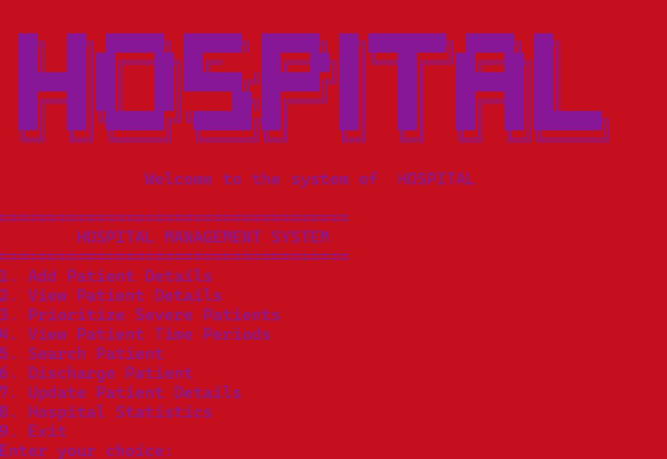
2.Main Menu

• Purpose: Central navigation hub for all system functions.
- User Actions: Enter a number (1–9) to select an option.
- Input Description: Numerical choice.
- Output Description: Confirmation or transition to the selected function.
- Navigation: Returns to Main Menu after completing each task unless Exit is chosen.
3.Add Patient Details
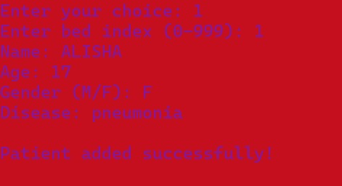
Screenshot:
Purpose: Collects patient information and stores it in the system.
- User Actions: Enter bed index, name, age, gender, disease.
- Input Description:
  - Bed index (integer, 0–999)
  - Name (string, single word)
  - Age (integer)
  - Gender (M/F)
  - Disease (string, single word)
- Output Description: Displays “Patient added successfully!” and assigns doctor time (30 or 60 mins).
- Navigation: Returns to Main Menu after completion
View Patient Records
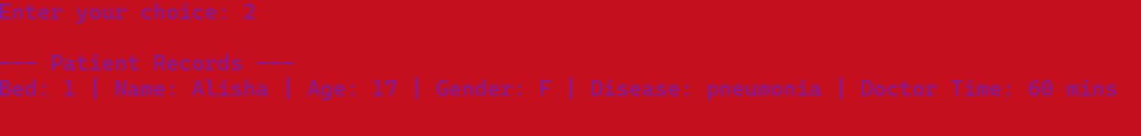
Screenshot:

Purpose: Displays all patient records.
- User Actions: None; system prints records automatically.
- Input Description: No input required.
- Output Description: List of patients with bed, name, age, gender, disease, doctor time.
- Navigation: Returns to Main Menu after display.
Prioritize Patients
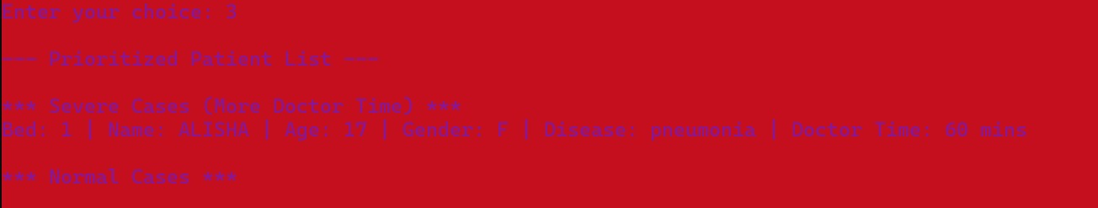
Screenshot
Purpose: Separates patients into severe and normal categories.
- User Actions: None; system categorizes automatically.
- Input Description: No input required.
- Output Description: Two lists: Severe Cases (60 mins) and Normal Cases (30 mins).
- Navigation: Returns to Main Menu after display.
Search Patient
Screenshot:
Purpose: Finds a patient by name.
- User Actions: Enter patient name.
- Input Description: Name (string, exact match).
- Output Description: Displays patient details if found, else “Patient not found.”
- Navigation: Returns to Main Menu after search.

Discharge Patient:
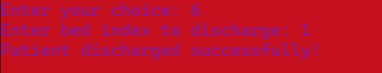
Screenshot:
Purpose: Removes a patient record and frees the bed.
- User Actions: Enter bed index.
- Input Description: Bed index (integer).
- Output Description: “Patient discharged successfully!” or error message if invalid.
- Navigation: Returns to Main Menu after completion.
Update Patient Details
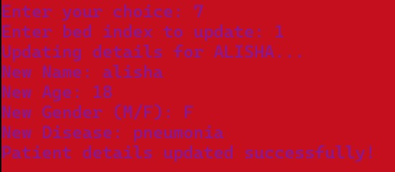
Screenshot:

Purpose: Updates patient information and recalculates doctor time.
- User Actions: Enter bed index, then new details.
- Input Description:
  - Bed index (integer)
  - New name, age, gender, disease
- Output Description: “Patient details updated successfully!”
- Navigation: Returns to Main Menu after update.
Hospital Statistics:
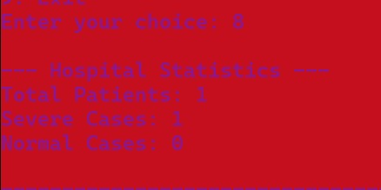
Screenshot:
Purpose: Provides summary of hospital records.
- User Actions: None; system calculates automatically.
- Input Description: No input required.
- Output Description: Total patients, severe cases, normal cases.
- Navigation: Returns to Main Menu after display.
Exit Screen
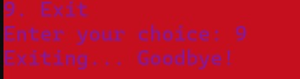
Screenshot:
Purpose: Ends the program gracefully.
- User Actions: Select option 9 from Main Menu.
- Input Description: Choice = 9.
- Output Description: “Exiting… Goodbye!” message.
- Navigation: Program terminates
10.3 Sample Test Cases
Test Case 1: Add Patient Record
- Input:
  - Bed index: 2
  - Name: Ali
  - Age: 45
  - Gender: M
  - Disease: Cancer
• Expected Output:
  - Patient record stored successfully.
  - Doctor time assigned = 60 minutes (since Cancer is severe).
  - Message: “Patient added successfully!”
- Actual Output:
  - Patient record stored with correct details.
  - Doctor time = 60 minutes.
  - Confirmation message displayed.
- Status: Pass – Function works as intended

Test Case 2: Search Patient by Name
- Input:
  - Search name: Ali
- Expected Output:
  - System finds patient record at bed index 2.
  - Displays: Name, Age, Gender, Disease, Doctor Time.
- Actual Output:
  - Patient details printed correctly.
- Status: Pass – Sequential search returns correct record.
Test Case 3: Discharge Patient
- Input:
  - Bed index: 2
- Expected Output:
  - Patient record cleared (name, age, gender, disease, doctor time reset).
  - Patient count decremented.
  - Message: “Patient discharged successfully!”
- Actual Output:
  - Patient record cleared.
  - Patient count updated.
  - Confirmation message displayed.
- Status: Pass – Bed freed and record removed correctly.

11. Future Improvements
• Performance Optimizations: Use dynamic data structures (e.g., vectors) and smarter file handling to reduce memory waste and speed up operations.
- Feature Extensions: Add authentication, appointment scheduling, billing, and reporting to make the system more complete.
- Scalability: Integrate a database (e.g., MySQL/SQLite) and indexing for handling larger datasets efficiently.
- User Experience: Develop a GUI, improve input validation, and add visual feedback for severe vs. normal patients.
- Algorithm Alternatives: Replace sequential search with binary search or hashing; use priority queues for severe cases.
- Real-World Applications: Extend to full hospital modules (pharmacy, labs, HR), add cloud integration, and analytics dashboards.
Conclusion:
This project delivered a functional Hospital Management System with core features like adding, searching, updating, and discharging patients. It strengthened my understanding of discrete mathematics concepts such as algorithms, complexity, and logical classification. Challenges with data handling and consistency were overcome, improving my problem-solving skills. Overall, the project shows how discrete mathematics supports practical implementation, enhancing both my competence as a developer and my ability to apply theory to real-world systems.

13. References & Learning Sources
• Video Demo: Project demonstration video on LinkedIn (insert link).
- Textbooks:
  - Rosen, Kenneth H. Discrete Mathematics and Its Applications, 8th Edition.

.

